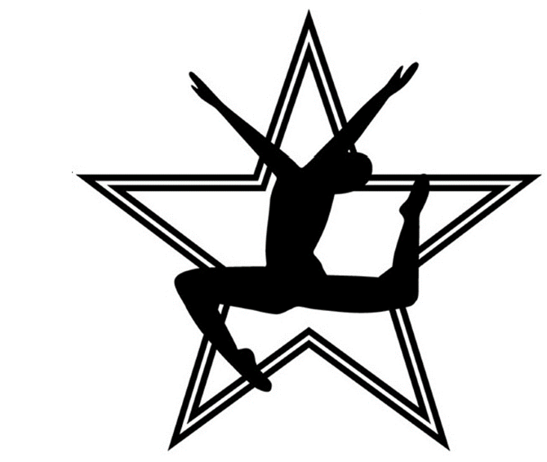
Leigh’s School of Dance
Rising Star Team Schedule
June 22nd – July 7th

 | Wednesday
5:00-5:30 | 6-8 Ballet | 5:00-5:30 | 9-11 Tap
5:30-6:00 | 6-8 Tap | 5:30-6:00 | 9-11 Ballet
6:00-6:30 | 6-8 Acro/Leaps & Turns | 6:00-6:30 | 9-11 Jazz/Hip Hop
6:30-7:00 | 5-8 Intro To Rising | 6:30-7:00 | 9-11 Acro
7:00-8:00 | 11 & Up Lyrical Contemporary | 6:00-7:30 | 9 & Up Intro To Rising
8:00-9:00 | 11 & Up Jazz

 | Thursday
6:00-7:00 | 9-11 Ballet Leaps & Turns | 5:30-6:00 | 11 & Up Tap
7:00-8:00 | 9-11 Acro | 6:00-7:00 | 11 & Up Acro
 |  | 7:00-8:00 | 11 & Up Ballet Leaps & Turns
5:30-6:30 | 6-8 Ballet Leaps & Turns
6:30-7:00 | 6-8 Jazz Hip Hop | 5:30-7:00 | 5-8 Intro To Rising
7:00-8:30 | 9-12 Intro To Rising
Required Classes
5-8 Intro to Rising Dancers will take 2.5 Hour per week for a total of $95.00
9 & Up Intro to Rising Dancers will take 4 Hours per week for a total of $105.00
6-8 Dancers will take 3 Hours per week for a total of $105.00
9-11 Dancers will take 4 Hours per week for a total of $115.00
11 & Up Dancers will take 4.5 Hour per week for a total of $120.00

Required Dance Attire
~Ballet: Dancers will need pink tights, black leotard, pink ballet shoes, hair in a bun
~Jazz: Dancers will need jazz shoes. black leotard, (Dancers may choose to add shorts)
~Tap: Dancers will need tap shoes
~Hip Hop: Dancers will need any athletic wear and tennis shoes
~Intro: Dancers will need pink tights, black leotard, pink ballet shoes, tap and jazz shoes, hair in a bun.

Class Class Description Required Attire
Ballet | Ballet is the foundation of dance. Students will learn proper technique, terminology, and alignment. | Pink Ballet shoes, Pink tights that go in ballet shoes, Black leotard, Hair secured neatly into bun.  *Wed & Thurs. Level 5 & 4 Ballet classes may wear any color leotard.*
Leaps & Turns | Dancers will learn proper jazz technique for pirouettes, battements, leaps, etc. while improving strength and flexibility, | Form fitting dance attire such as a leotard, booty shorts, sports bra, leggings, etc., jazz shoes are required.
Tap | Develops rhythm, musicality, and coordination. | Dance clothes that are comfortable and moveable. Full sole tap shoes are preferred.
Contemporary / Lyrical | Dancers will be introduced to different methods of modern technique, strength, and agility, | Form fitting dance attire such as leotard, booty shorts, sports bra, leggings, etc.
Hip Hop | An energetic and fast paced class that introduces different hip hop styles and movement. | Dance attire that is comfortable and moveable. Sneakers with ties required.
Acro | Acro class helps build dancers strength and flexibility while learning acrobatic skills they can utilize in dances. | Dance clothes that are comfortable and moveable.
Stylized Jazz | This class focuses on different jazz styles from commercial dance to Broadway jazz. | Form fitting dance attire such as a leotard, booty shorts, sports bra, leggings, etc., jazz shoes are required.
Pointe | This class is teacher approved and is continuing education in advanced ballet. | Pink Ballet shoes, Pink tights that go in ballet shoes, Black leotard, Hair secured neatly into bun. May wear a skirt.
Pointe Variations | Teacher Approved*  Will learn solo variations from classical ballets to improve upon advanced ballet/pointe technique. | Same as pointe, may wear practice tutu if dancer has one.
Intro  Hip Hop/Acro | Mix of Acro and Hip Hop class. Optional for intro to comp dancers to add on in addition to Into to Comp technique. | Acro attire and Hip Hop shoes
Intro to  Comp Technique | Dancers will be introduced to competitive level dancing in tap, ballet and jazz. | Black Ballet Attire with leggings shorts to go over Ballet, Tap, and Jazz Shoes

Required Classes:
Introduction- Intro level students are only required to take Wednesday and Thursday~

Petite- Required to take classes on both Wednesday and Thursday, P1=3.5 Hours / P2 4 Hours Total~

Junior- Required to take classes on both Monday and Thursday, Junior 1 & 2= 5.5 Hours Total~

Teens- Required to take classes on Tuesday, and Thursday, 7 Hours Total~

Seniors- Required to take classes on Monday and Thursday, 7 Hours Total~

*Optional Classes

