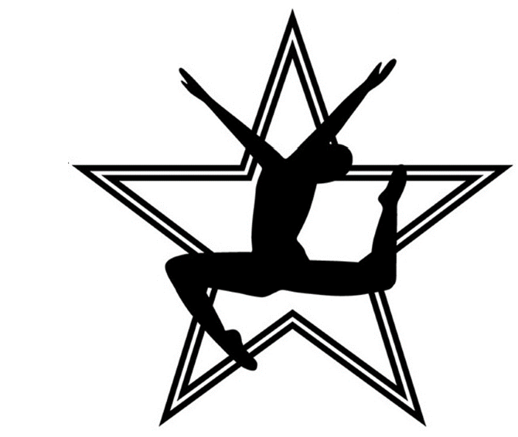
Leigh’s School of Dance
Competition Team Schedule
July 11th - August 4th
 | Mo | nday
4:30-5:00 | Senior Tap | 4:30-5:00 | Junior 1 Tap
5:00-6:30 | Senior Ballet/Pointe | 5:00-6:00 | Junior 1 Ballet
6:30-7:00 | Senior Variations | 6:00-7:00 | Junior 1 Leaps and Turns
7:00-8:00 | Senior Contemporary/Lyrical | 7:00-7:30 | Junior 1 Contemporary Lyrical
 |  | 7:30-8:00 | Junior 1 Jazz

 | Tue | sday
4:30-5:00 | Teen Tap | 4:30-5:00 | Junior 2 Tap
5:00-6:30 | Teen Ballet/Pointe | 5:00-6:00 | Junior 2 Ballet
6:30-7:00 | Teen Variations | 6:00-7:00 | Junior 2 Leaps and Turns
7:00-8:00 | Teen Contemporary / Lyrical | 7:00-7:30 | Junior 2 Contemporary
 |  | 7:30-8:00 | Junior 2 Hip Hop

 | Wednesday
4:30-5:30 | Teen/Senior Acro* | 4:30-5:00 | Petite 1 Tap
5:30-6:30 | Teen/Senior Leaps & Turns | 5:00-6:00 | Petite 1 Ballet/Lyrical
6:30-7:30 | Teen/Senior Jazz/Hip Hop | 5:00-5:30 | Petite 2 Tap
7:30-8:00 | Teen/Senior Heels Class | 5:30-6:00 | Petite 2 Acro
 |  | 5:30-6:30 | Intro 5-8yrs Ballet/Tap
 |  | 6:30-8:00 | Intro 9 and Up

 | Thursday
5:00-5:30 | Teen/Senior Stretch Pilates* | 5:00-5:30 | Petite 1 Hip Hop
5:30-6:30 | Teen/Senior Leaps/Turns* | 5:30-6:00 | Petite 2 Hip Hop
6:30-7:00 | Teen/Senior MT/Choreo* | 6:00-6:30 | Petite 2 Lyrical/Contemporary
7:00-8:00 | Teen/Senior Acro* | 7:00-7:30 | Petite 2 Leaps & Turns
6:30-7:00 | Junior 2 Acro | 5:30-6:30 | Petite 1 AND Intro 5-8 Ballet/Tap
6:30-7:00 | Junior 1 Leaps & Turns | 6:30-8:00 | Intro 9&Up Ballet/Leaps Turns/Tap
7:00-8:00 | Junior 1&2 Choreo Combo

Class Class Description Required Attire
Ballet | Ballet is the foundation of dance. Students will learn proper technique, terminology, and alignment. | Pink Ballet shoes, Pink tights that go in ballet shoes, Black leotard, Hair secured neatly into bun.  *Wed & Thurs. Level 5 & 4 Ballet classes may wear any color leotard.*
Leaps & Turns | Dancers will learn proper jazz technique for pirouettes, battements, leaps, etc. while improving strength and flexibility, | Form fitting dance attire such as a leotard, booty shorts, sports bra, leggings, etc., jazz shoes are required.
Tap | Develops rhythm, musicality, and coordination. | Dance clothes that are comfortable and moveable. Full sole tap shoes are preferred.
Contemporary / Lyrical | Dancers will be introduced to different methods of modern technique, strength, and agility, | Form fitting dance attire such as leotard, booty shorts, sports bra, leggings, etc.
Hip Hop | An energetic and fast paced class that introduces different hip hop styles and movement. | Dance attire that is comfortable and moveable. Sneakers with ties required.
Acro | Acro class helps build dancers strength and flexibility while learning acrobatic skills they can utilize in dances. | Dance clothes that are comfortable and moveable.
Stylized Jazz | This class focuses on different jazz styles from commercial dance to Broadway jazz. | Form fitting dance attire such as a leotard, booty shorts, sports bra, leggings, etc., jazz shoes are required.
Pointe | This class is teacher approved and is continuing education in advanced ballet. | Pink Ballet shoes, Pink tights that go in ballet shoes, Black leotard, Hair secured neatly into bun. May wear a skirt.
Pointe Variations | Teacher Approved*  Will learn solo variations from classical ballets to improve upon advanced ballet/pointe technique. | Same as pointe, may wear practice tutu if dancer has one.
Intro  Hip Hop/Acro | Mix of Acro and Hip Hop class. Optional for intro to comp dancers to add on in addition to Into to Comp technique. | Acro attire and Hip Hop shoes
Intro to  Comp Technique | Dancers will be introduced to competitive level dancing in tap, ballet and jazz. | Black Ballet Attire with leggings shorts to go over Ballet, Tap, and Jazz Shoes

Required Classes:
Introduction- Intro level students are required to take Wednesday and Thursday~

Petite- Required to take classes on both Wednesday and Thursday, P1=3.5 Hours / P2 4 Hours Total~

Junior- Required to take classes on both Monday and Thursday, Junior 1 & 2= 5.5 Hours Total~

Teens- Required to take classes on Tuesday, and Wednesday, 7 Hours Total~ (must pick acro Wed or TH)

Seniors- Required to take classes on Monday and Wednesday, 7 Hours Total~

*Optional Classes* Classes will be capped at 8 Hours*

Pay Scale:
.5 Hour | $40 |  | 5.5 Hours | $190
1 Hour | $60 |  | 6 Hours | $205
1.5 Hours | $90 |  | 6.5 Hours | $220
2 Hours | $100 |  | 7 Hours | $235
2.5 Hours | $125 |  | 7.5 Hours | $250
3 Hours | $135 |  | 8 + Hours | $265
3.5 Hours | $145
4 Hours | $150
4.5 Hours | $160
5 Hours | $175

*= Optional Class
Password for online enrollment LSOD

